Candidate name: Daren (NJC)
Centre number: NA
Index number: NA
Programming language used: Python 3
Question 1
Evidence 1

def exists(current_list, target):
for i in range(len(current_list)):
if target == current_list[i]:
return i
return -1

Inventory = []
ItemTypes = []
ItemCounts = []

f = open("INVENTORY.TXT")
for line in f:
current_item = line.strip()
Inventory.append(current_item)
current_index = exists(ItemTypes, current_item)
if current_index == -1:
ItemTypes.append(current_item)
ItemCounts.append(1)
else:
ItemCounts[current_index] += 1
f.close()

print("{0:<20}{1:<8}\n".format("ItemType", "Count"))
for i in range(len(ItemTypes)):
print("{0:<20}{1:<8}".format(ItemTypes[i], ItemCounts[i]))

Evidence 2

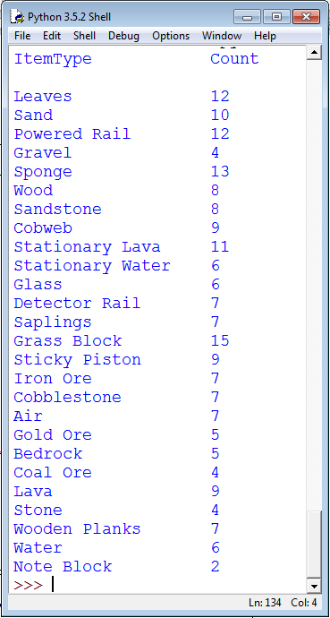

Question 2
Evidence 3

A: CheckDigit 🡨 CalCheckDigit(newNumber, Total)

B: RETURN "X"

C: RETURN CONCATENATE(Number, CheckDigit)

Evidence 4

def CalCheckDigit(Number, Total):
if len(Number) > 1:
Digit = int(Number[0])
Total = Total + (Digit * (len(Number) + 1))
newNumber = Number[1:]
CheckDigit = CalCheckDigit(newNumber, Total)
else: # len(Number) == 1
Digit = int(Number[0])
Total = Total + (Digit * (len(Number) + 1))
CalcModulus = Total % 11
CheckValue = 11 - CalcModulus
if CheckValue == 11:
return "0"
elif CheckValue == 10:
return "X"
else:
return str(CheckValue)

if len(Number) == 9:
return Number + CheckDigit
else:
return CheckDigit

f = open("ISBNPRE.TXT")
rawISBNs = []
for line in f:
rawISBNs.append(line.strip())
print(CalCheckDigit(rawISBNs[-1], 0))

Evidence 5

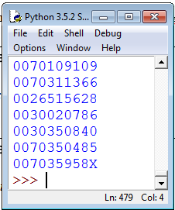

Question 3
Evidence 6

class ConnectionNode():

def __init__(self):
self._DataValue = ""
self._LeftChild = 0
self._RightChild = 0

def GetDataValue(self):
return self._DataValue

def SetDataValue(self, newValue):
self._DataValue = newValue

def GetLeftChild(self):
return self._LeftChild

def SetLeftChild(self, newLeft):
self._LeftChild = newLeft

def GetRightChild(self):
return self._RightChild

def SetRightChild(self, newRight):
self._RightChild = newRight

class LinkedList():

def __init__(self):
# note: index zero holds a dummy ConnectionNode instance
self._RobotData = [None] + [ConnectionNode() for x in range(25)]
for i in range(1, len(self._RobotData) - 1):
self._RobotData[i].SetLeftChild(i + 1)
self._Root = 1
self._NextFreeChild = 1

myLL = LinkedList()

Evidence 7

def FindNode(self, NodeValue):
Found = False
CurrentPosition = self._Root
while not Found and CurrentPosition <= 25:
if self._RobotData[CurrentPosition].GetDataValue() == \
NodeValue:
Found = True
else:
CurrentPosition += 1
if CurrentPosition > 25:
return 0
else:
return CurrentPosition

def AddToRobotData(self, NewDataItem, ParentItem, ThisMove):
# Add link: ParentItem -> newDataItem (on ThisMove of ParentItem)
# ThisMove should only be: "L", "R" or "X"
if self._Root == 1 and self._NextFreeChild == 1: # is empty
# update NextFreeChild
self._NextFreeChild = \
self._RobotData[self._NextFreeChild].GetLeftChild()
# update new RobotData node
self._RobotData[self._Root].SetLeftChild(0)
self._RobotData[self._Root].SetDataValue(NewDataItem)
else:
# check if parent exists
ParentPosition = self.FindNode(ParentItem)
if ParentPosition > 0: # parent exists
# check if child exists
ExistingChild = self.FindNode(NewDataItem)
if ExistingChild > 0: # child exists
ChildPointer = ExistingChild
else:
ChildPointer = self._NextFreeChild
self._NextFreeChild = self._RobotData[ \
self._NextFreeChild].GetLeftChild()
self._RobotData[ChildPointer].SetLeftChild(0)
self._RobotData[ChildPointer].SetDataValue(NewDataItem)
if ThisMove == "L":
self._RobotData[ParentPosition].\
SetLeftChild(ChildPointer)
else:
self._RobotData[ParentPosition].\
SetRightChild(ChildPointer)

Evidence 8

def OutputData(self):
print("Root: " + str(self._Root))
print("NextFreeChild: " + str(self._NextFreeChild))
print("RobotData:")
print("{0:<8}{1:<8}{2:<8}{3:<8}".format("Index", "Data", \
"Left", "Right"))
for i in range(1, len(self._RobotData)):
print("{0:<8}{1:<8}{2:<8}{3:<8}".format(i,
self._RobotData[i].GetDataValue(), \
self._RobotData[i].GetLeftChild(), \
self._RobotData[i].GetRightChild()))

Evidence 9

myLL = LinkedList()
f = open("SEARCHTREE.TXT")
for line in f:
line = line.strip().split(",")
myLL.AddToRobotData(line[0], line[1], line[2])
myLL.OutputData()

Evidence 10

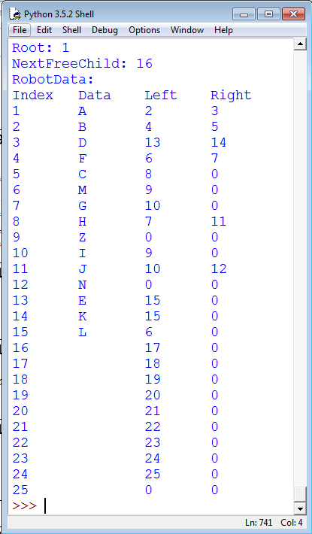

Evidence 11

def DoPreOrderTraversal(self, CurrentIndex, PreviousPath):
Current = self._RobotData[CurrentIndex]
newPath = PreviousPath + Current.GetDataValue()
if Current.GetDataValue() == "Z":
print(newPath)
if Current.GetLeftChild() != 0:
self.DoPreOrderTraversal(Current.GetLeftChild(), newPath)
if Current.GetRightChild() != 0:
self.DoPreOrderTraversal(Current.GetRightChild(), newPath)

def PreOrderTraversal(self):
self.DoPreOrderTraversal(self._Root, "")

Evidence 12

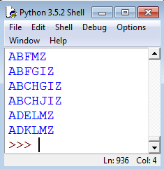

Question 4
Evidence 13

def declareGrid():
# grid[row][col]
grid = [[0, 0, 0, 0], \
[0, 0, 0, 0], \
[0, 0, 0, 0], \
[0, 0, 0, 0]]
return grid

def initialiseGrid(grid):
grid[0][0] = 4
grid[0][1] = 3
grid[0][2] = 2
grid[0][3] = 1

grid[1][0] = 1
grid[1][1] = 2
grid[1][2] = 4
grid[1][3] = 3

grid[2][0] = 3
grid[2][1] = 4
grid[2][2] = 1
grid[2][3] = 2

grid[3][0] = 2
grid[3][1] = 1
grid[3][2] = 3
grid[3][3] = 4

return grid

grid = declareGrid()
grid = initialiseGrid(grid)

Evidence 14

def displayGrid(grid):
for i in range(len(grid)):
for j in range(len(grid[i])):
if j < len(grid[i]) - 1:
print(str(grid[i][j]), end = " ")
else:
print(str(grid[i][j]))

displayGrid(grid)

Evidence 15

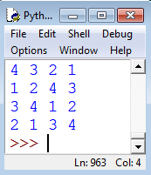

Evidence 16

def swapCol(c1, c2, grid):
# swaps 2 specific columns: c1 and c2
for i in range(len(grid)):
grid[i][c1], grid[i][c2] = grid[i][c2], grid[i][c1]
return grid

def swapRow(r1, r2, grid):
# swaps 2 specific rows: r1 and r2
grid[r1], grid[r2] = grid[r2], grid[r1]
return grid

def swapRandRow(grid):
import random
print("Transformation 1: Swaps two rows " + \
"in the same quadrants")
if random.randint(0, 1):
return swapRow(0, 1, grid)
else:
return swapRow(2, 3, grid)

def swapRandCol(grid):
import random
print("Transformation 2: Swaps two columns " + \
"in the same quadrants")
if random.randint(0, 1):
return swapCol(0, 1, grid)
else:
return SwapCol(2, 3, grid)

def swapQuadRow(grid):
print("Transformation 3: Swaps the top and bottom " + \
"quadrant rows entirely")
return swapRow(0, 2, swapRow(1, 3, grid))

def swapQuadCol(grid):
print("Transformation 4: Swaps the left and right " + \
"quadrant columns entirely")
return swapCol(0, 2, swapCol(1, 3, grid))

import random
choices = [1, 2, 3, 4]
choice1 = random.randint(1, len(choices) - 1)
choices = choices[:choice1] + choices[choice1 + 1:]
choice2 = choices[random.randint(1, len(choices) - 1)]

grid = declareGrid()
grid = initialiseGrid(grid)
displayGrid(grid)

if choice1 == 1 or choice2 == 1:
grid = swapRandRow(grid)
displayGrid(grid)
if choice1 == 2 or choice2 == 2:
grid = swapRandCol(grid)
displayGrid(grid)
if choice1 == 3 or choice2 == 3:
grid = swapQuadRow(grid)
displayGrid(grid)
if choice1 == 4 or choice2 == 4:
grid = swapQuadCol(grid)
displayGrid(grid)
Evidence 17

